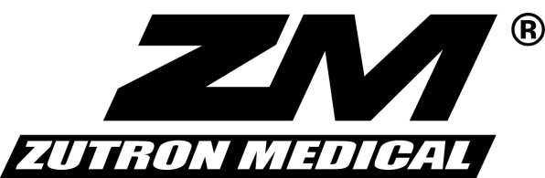

QUALITY AGREEMENT CHANGE NOTICE

Zutron Medical, LLC has conducted validation and verification testing to confirm that your product, component or part, as currently designed and manufactured, is compatible for use with Zutron Medical’s products.

To be able to monitor and ensure continued compatibility of your product, component or part, with Zutron Medical’s products, we require you to provide us timely notification of any field action, regulatory filing updates or material changes to your product, component or part. Material changes for purposes of this notification requirement shall include all changes in the engineering, manufacture, materials, and/or component parts of that product, component or part that will or could alter the performance and/or effectiveness of the product, component or part, including any alteration in the validated performance of the product, component or part.
By signing below, you agree to provide Zutron Medical, LLC with notice of any field action, regulatory filing updates or material changes to the product, component or part at least thirty (30) days prior to implementation of any such change. Any such notification should be sent to:
Product Quality, Risk Management
Zutron Medical, LLC
17501 W 98th Street - #40-27
Lenexa, Kansas 66219

Please note: this agreement is valid until December 31, 2020. Should you have any questions or wish to discuss any of the foregoing, please do not hesitate to contact me at (913)553-3042 or jordan.hartong@zutron.com.
Respectfully, Read, understood and agreed to
__Jordan Hartong_________________ _______________________________________
Jordan Hartong Title :___________________________________
VP of Operations Company: _______________________________
Street : _________________________________
_November 13, 2018____________________ City/State/Zip: ___________________________
Date Phone : _________________________________

